Lab 3: Tableau Basic Functions and Advanced I:

Name: Khush Domadiya

1. Connect tableau to the data:

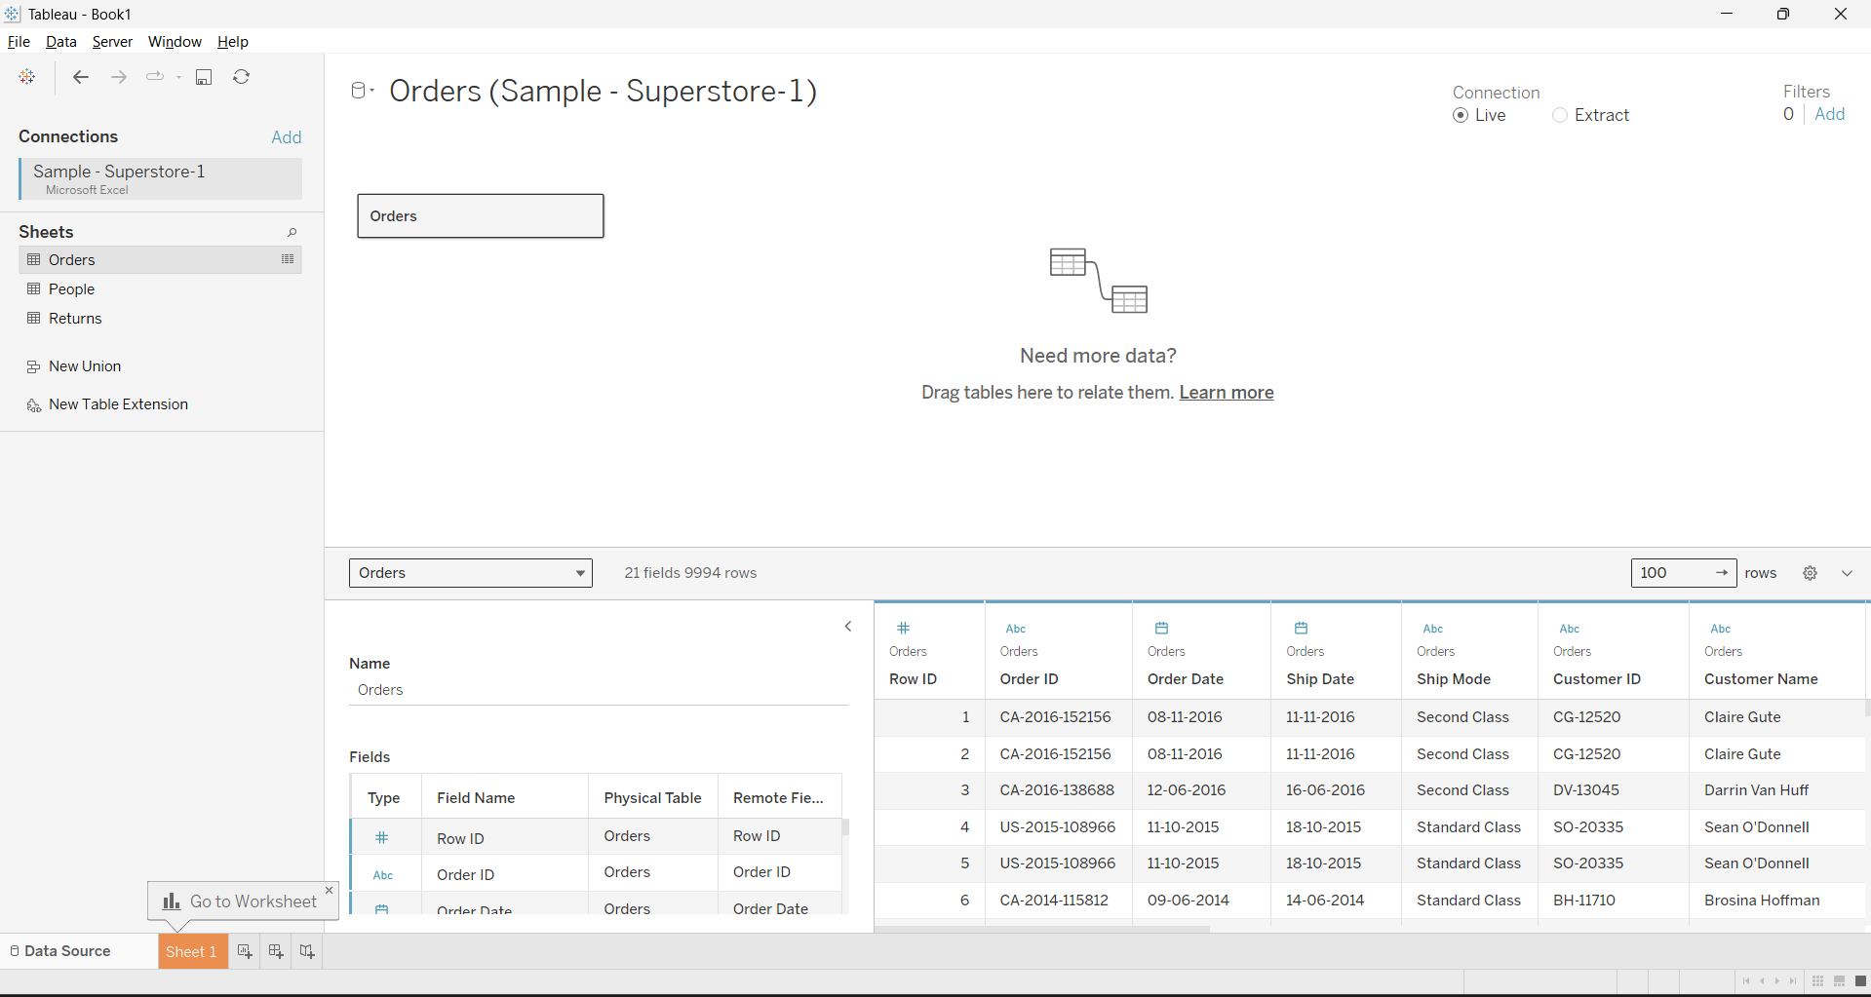

(1). to the excel file;

(2). to the database/data warehouse: correlate multiple tables;

2. Analyze data in the View:

(1). create bar/column charts;

a. Use Category and Sum of the Sales to create a column chart:

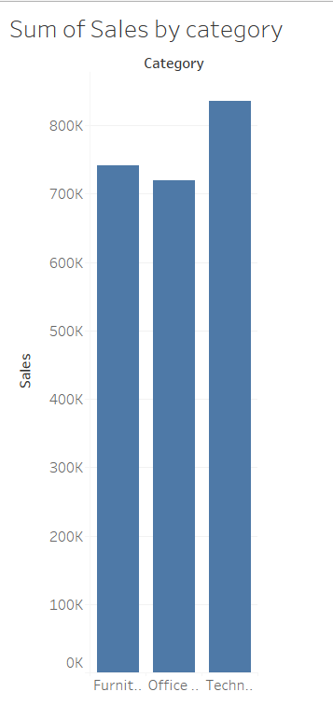

b. Use Category, sub-category and Sum of the Sales to create a bar chart:

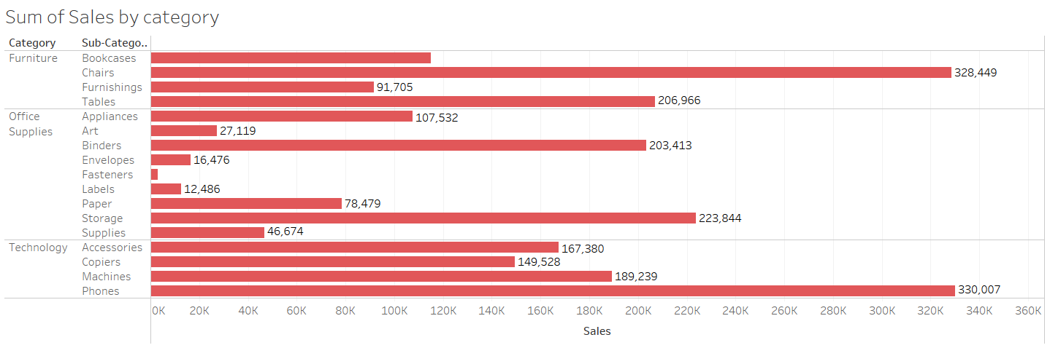

1. . Use additional Measurements (Sum of the Profit) for color comparison:

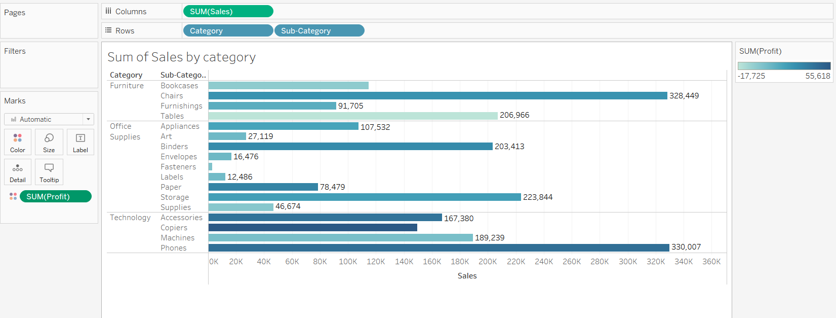

(3). Create cross tables:

a. Use Category, Sub-Category, Sum of the profit, Sum of the sales to create a cross table;

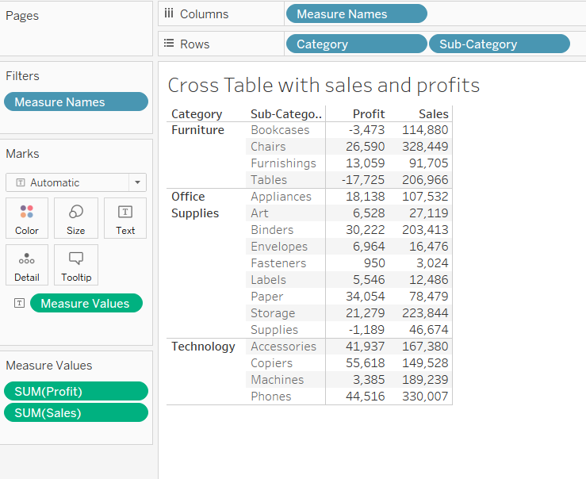

b. Use Sum of all the measurements, Category, and Sub-Category to create a cross table:

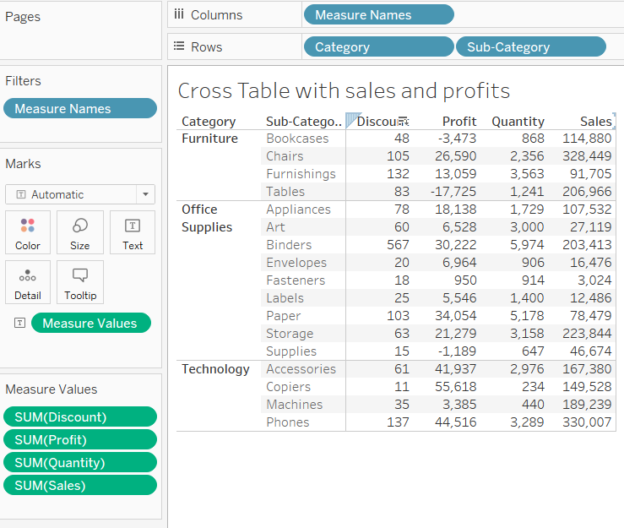

3. Filter the Data:

(1). Filter the categorical dimensions; (category and sub-category)

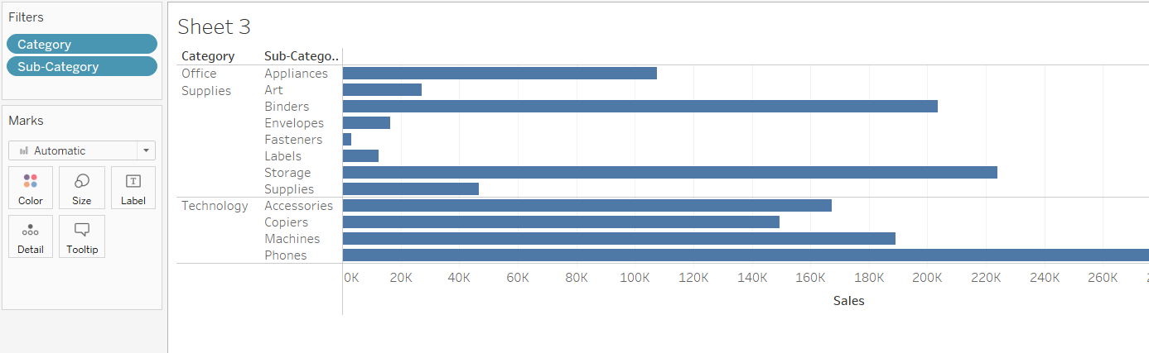

1. . Filter the measurements;

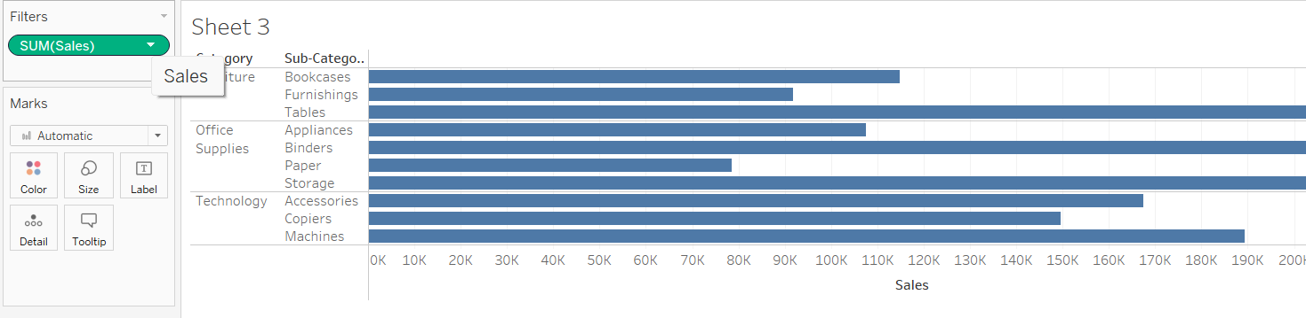

1. . Use Region as the additional Filter option on the side;

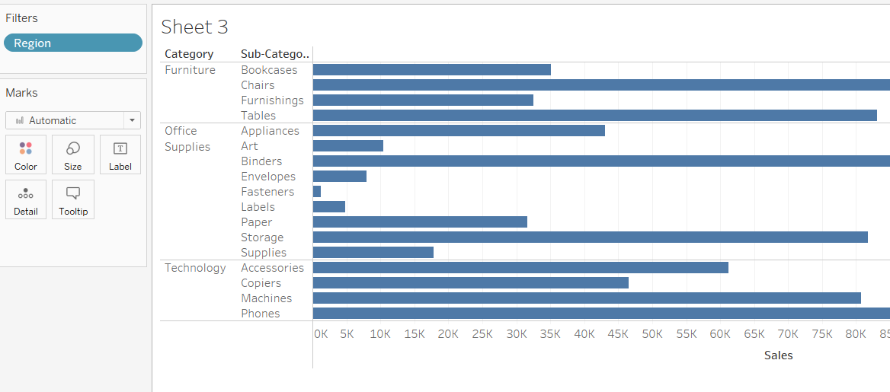

4. Computed Sort and Manual Sort;

(1). Sort bar charts by values;

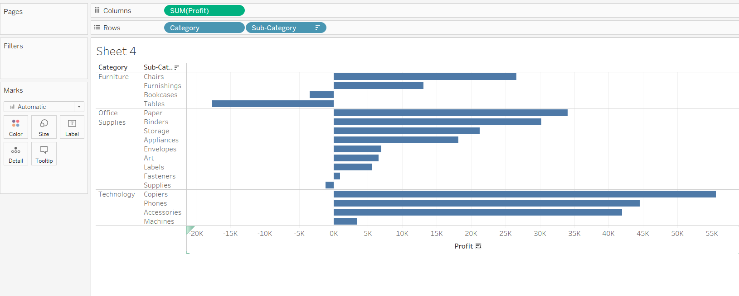

1. . Sort bar charts by two categories;

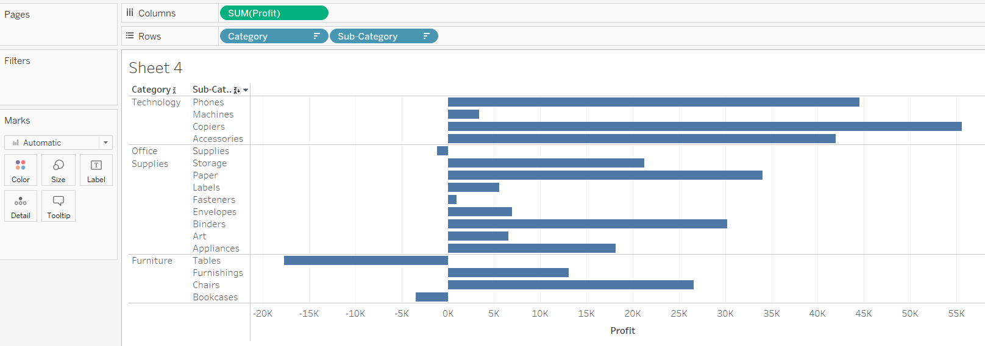

1. . Add additional criteria (Sum of quantity) to the existing sorting;

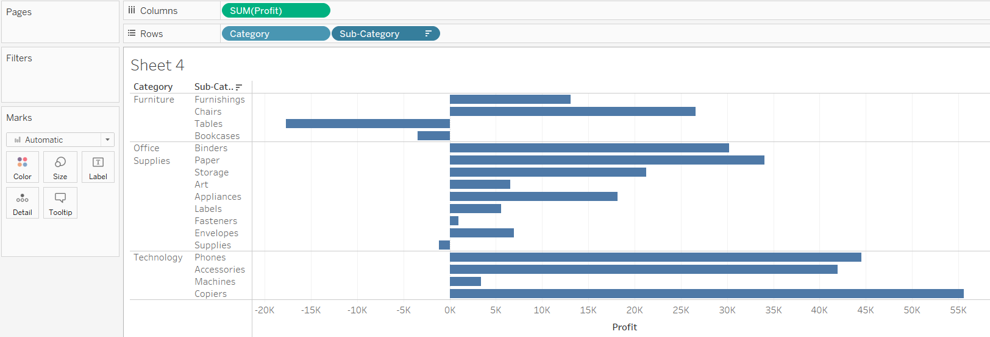

(4). Manual Sorting;

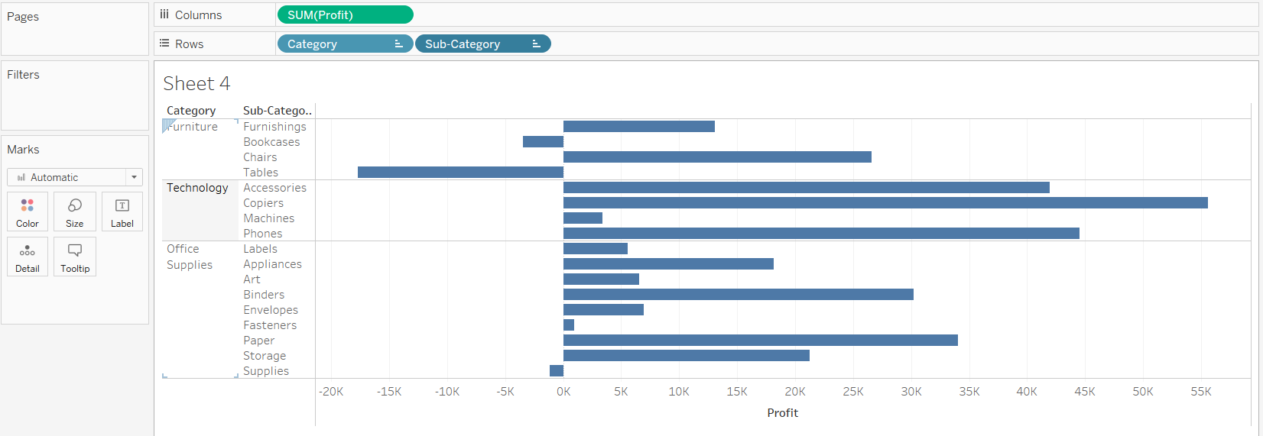

5. Share the views in the dashboard:

(1). Insert views into the dashboard;

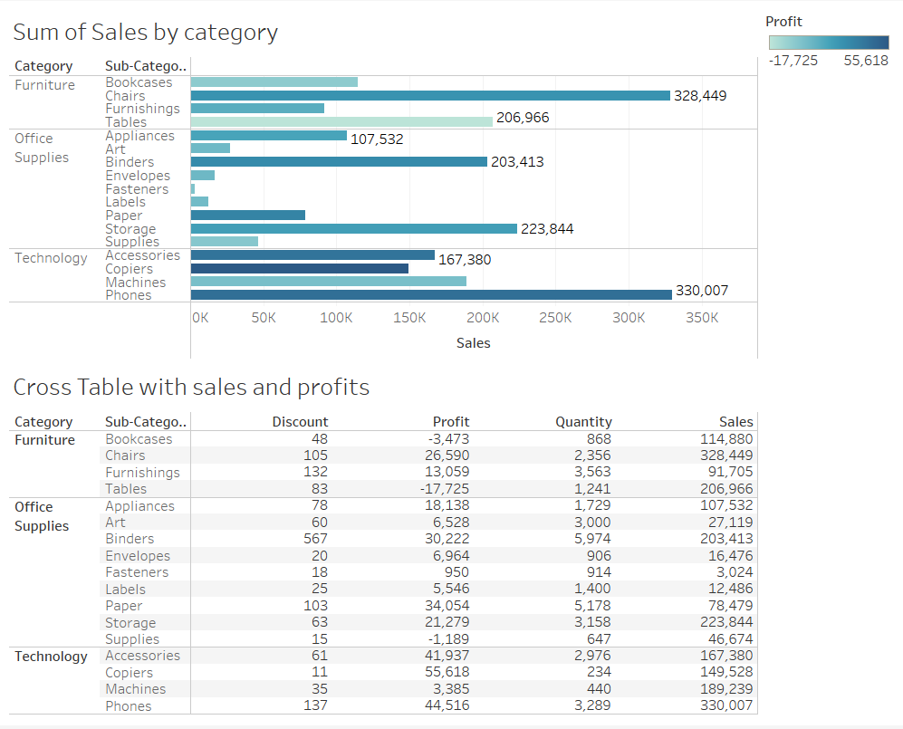

1. . Use one view to filter the other;

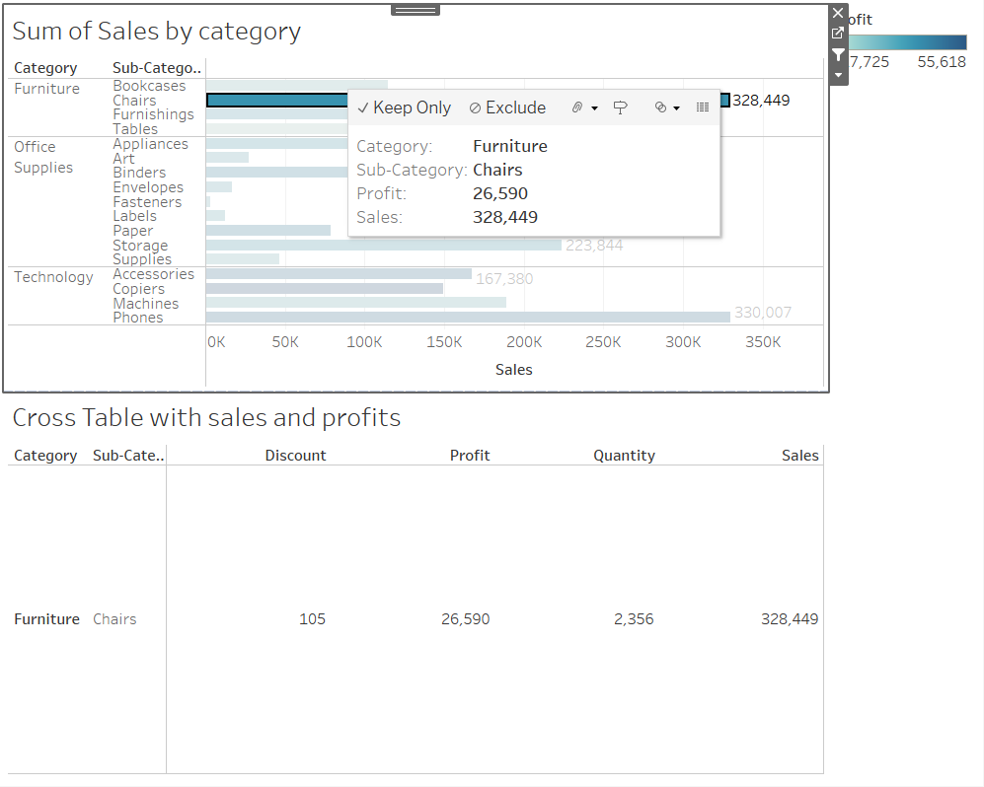

(3). Share and save the dashboard file;

